Advanced Sport Massage Course
November 4-5, 2017

This course is ideal for Massage Therapists who want to improve their knowledge and skills of
working with athletes in any environment.

It will provide participants with Sport Massage theory and practical techniques that can be utilized at sporting events, with athletic teams, or in their own Massage Therapist clinic setting.

It will greatly assist in the preparation for the Canadian Sport Massage Therapists Association's (CSMTA) written and practical examinations for Sport Massage Therapist Certification.

The Participants will gain:
1) An appreciation for the value of Sport Massage and its similarities or differences to classical
massage
2) A competency in several basic massage techniques, including: compressions, cross-fibre massage, jostling, effleurage, petrissage and mobilizations
3) A competency in the theory and techniques of Pre-event, Post-event and Inter-event Sport
Massage as well as Training and Maintenance Sport Massage
4) A quick and concise method of gathering useful information to make the Sport Massage session more effective and efficient
5) An understanding of the specific indications and contraindications for a variety of Sport
Massage circumstances
6) An understanding of the Physiological, Psychological and Performance effects of Sport
Massage
7) The ability to provide the athletes of the sports with an excellent quality of massage
8) An effective protocol when covering an athletic event

Excellent Learning Environment:
1) This workshop is highly practical in nature with an ongoing encouragement to change partners
so that each participant has an opportunity to practice on a wide variety of body types.
2) There will be dozens of demonstrations with each area of the body region broken down into
very manageable components. One of the advantages of Sport Massage is that so much is done
through clothing, so it is easier to provide a shorter demonstration, then have the participants
practice them, and then switch around and receive the techniques from their partner.
3) There will be some lecture and power point presentation to provide the theoretical portion of the workshop
4) All participants will receive a comprehensive printed manual that will reduce the need for note
taking during the course.

Massage Therapists and Massage Therapy students are encouraged to attend. Other Health Care
professionals such as Physiotherapists, Athletic Therapists, Chiropractors, Physicians, etc. are also welcome.

Massage Therapy Association Professional Development Credits:
* AB - MTAA approved 15 Primary Credits
* AB - NHPC approved 10 Primary Credits
* AB - RMTA approved 12 Primary Credits
* SK - MTAS approved 12 Primary Credits

Please bring: * Massage Table: 1 for every 2 participants required * 1 Bolster (preferred) or pillow per participant * Linens: 2 sheets, 2 towels, 2 face cradle covers per participant * Lubricant
Please wear comfortable clothes: Shorts, T-shirt, Sports bra for the practical portion

Instructor: Kip Petch B.P.E., RMT, SMT (C)
Certified Sport Massage Therapist
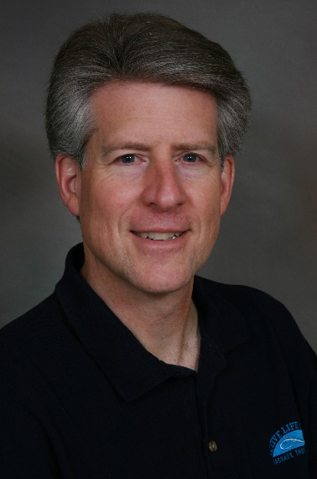
Kip has over 40 years experience in the Sport Massage and Sport Therapy field. He received his Bachelor of Physical Education degree with a major in Athletic Therapy and Coaching from the University of Alberta, his Massage Therapy education at Grant MacEwan and he attained his Sport Massage Therapist Certification from the CSMTA back in 1998. He is the former Sport Massage Therapist for the Edmonton Oilers, Edmonton Eskimos, several professional Soccer teams, the Canadian Women's National Soccer Team, the Canadian Men’s and Women’s Bobsleigh teams and has worked on several occasions with the Canadian Women's National Hockey Team

Kip has been a member of the Canadian Medical/Therapy Teams for 12 Major Games including 8 Olympic Games, 2 Pan Am Games, a Commonwealth Games and a Francophone Games and he has worked at dozens of other local, national and international events.

Kip has presented this course numerous times over the past 30 years, always refining the content and his instruction approach. He previously presented this course at the 2012, 2014 and 2015 CSMTA Conferences in Halifax, Montreal and Edmonton respectively, and he is very excited to
make this available once again in his home city of Edmonton!

Participants find Kip's course to be extremely beneficial and immediately practical and impactful when they return into their own environment, whether it is with high level athletes or with their regular clientele.

