SPORTS FIRST RESPONDER BLS COURSE
October 18-20, 2019
Lifemark Physiotherapy West Kelowna, BC

Stanley P. Leene
Red Cross Emergency Medical Responder Instructor
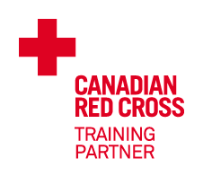

EMERGENCY FIRST RESPONDER TRAINING FOR SPORT MEDICINE PROFESSIONALS

- Universally recognized as the entry level emergency care provider certification within the EMS system.
- Certifies the sport medicine professional with a standardized level of emergency care as a “First Responder”.
- The First Responder integrates within the scope of their local EMS system, allowing better access, communication and collaboration during the preparation and execution of emergency medical interventions in the environment of sport.

COURSE CONTENT

- Mechanism of sports injuries
- Emergency action plan
- Assessment: primary and secondary assessment, vital signs, spinal injury assessment, transport decision
- SCAT 5 - Sport Concussion Assessment Tool
- Airway Management: oral pharyngeal airway, naso-pharyngeal airway, nasal canula,
non-rebreather mask, resuscitation pocket mask, bag valve mask, oxygen pulse oximeter
- Oxygen and suction
- CPR-BLS Basic Life Support,
automatic electrical defibrillation
- Bleeding, shock, pressure dressing, tourniquet, open fracture dressing
- Anaphylaxis: Epipen, Twinject, Allerject
- Spinal Injuries: cervical re-alignment, cervical collar, spinal board, scoop stretcher, KED
- Sport protective equipment removal and equipment extrication tools
- Reaching and moving patients
- MSK: closed and open fractures, dislocations, speed splint, SAM splint, slings, Sager femoral traction splint
- Medical Emergencies: respiratory, cardiac, diabetes, CVA, stroke, seizure
- Soft Tissue Injuries: impaled objects, extruded eye, neck laceration, amputation, burns
- Chest Trauma: open pneumothorax, flail chest
- Abdominal Trauma: evisceration
- Heat and cold injuries
- Childbirth and delivery
- Multiple casualty incidents and triage

INSTRUCTOR

Stanley P. Leene BPhEd, DipSIM, CAT(C), CSCS, EMR, CPedTech(C), CPed(C), EMRI
- Certified Athletic Therapist with 20 years of sports medicine field experience working with professional, university and national team athletes.
- 20 years of emergency care and sport medicine teaching experience at McMaster University, Sheridan College, Mount Royal College, Ski Patrol and Sports First Responder.
- Western Hockey League Sports First Responder Instructor 2000-2019.
- Head Athletic Therapist for the Canadian Women’s National Softball Team 1994-2004.
- Canadian Pro Rodeo Sports Medicine Team 2000-2010.
- Canadian Red Cross Emergency Medical Responder Instructor
- Emergency Medical Responder
- Basic Trauma Life Support
- Semi-Automatic Electrical Defibrillation
- ACUC Scuba Rescue
- DAN Emergency Oxygen Provider
- Canadian Alpine Ski Patrol Basic Life Support and On-hill Instructor
- World Judo 1993 Hamilton
- World Wrestling 1993 Toronto
- World University 1993 Buffalo
- World Basketball 1994 Toronto
- Pan Am Games 1995 Argentina
- World Karate 1996 Hamilton
- Summer Olympics 1996 Atlanta
- World Hockey 1997 Brantford
- World Softball 1998 Japan
- Pan Am Games 1999 Winnipeg
- World Softball 2002 Saskatoon
- Canadian Finals Rodeo 2005-06 Edmonton
- World Figure Skating 2006 Calgary

PRE-REQUISITES

- Sport Medicine Professional / Student in training
- Athletic Therapist / Trainer / Student
- Canadian Athletic Therapist Association
- Doctor of Chiropractic / Student
- Royal College of Chiropractic Sport Sciences
- Medical Doctor / Student
- Canadian Academy Sport & Exercise Medicine
- Physical Therapist / Student
- Sport Physiotherapy Canada
- Registered Nurse / Student
- Registered Massage Therapist / Student
- Sport Massage Therapist / Student
- Canadian Sport Massage Therapist Association

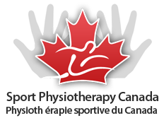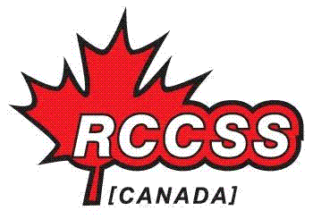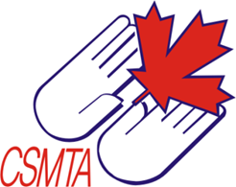

COURSE LOCATION, DATE and TIME

Lifemark Physiotherapy West Kelowna
111 - 2231 Louie Drive
Westbank, BC
V4T 3K3

Sports First Responder Certification
Friday October 18, 2019 4:00 pm - 10:00 pm
Saturday October 19, 2019 9:00 am - 9:00 pm
Sunday October 20, 2019 9:00 am - 9:00 pm

Sports First Responder Re-Certification
Saturday October 19, 2019 9:00 am - 6:00 pm
Sunday October 20, 2019 9:00 am - 6:00 pm

REGISTRATION FEE

SFR Certification $495 SFR Re-Certification $395

- Canadian Red Cross First Responder Certification (valid 3 years)
- Includes CPR-BLS Basic Life Support
- 2015 ILCOR Standards for CPR and First Aid
- Canadian Red Cross First Responder wall certificate and wallet card
- Sports First Responder wall certificate
- Emergency Care for Professional Responders

WHAT TO BRING

- Fanny pack
- Penlight
- Lister bandage scissors
- Emergency shears
- Stethoscope
- BP Cuff
- Watch with second hand
- Knee pads
- Food and snacks
- Resuscitation pocket mask with oxygen inlet
- Emergency Care for Professional Responders
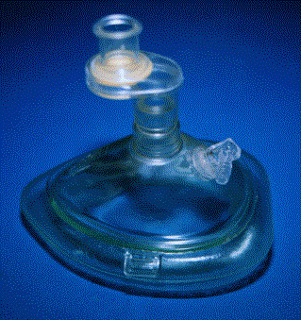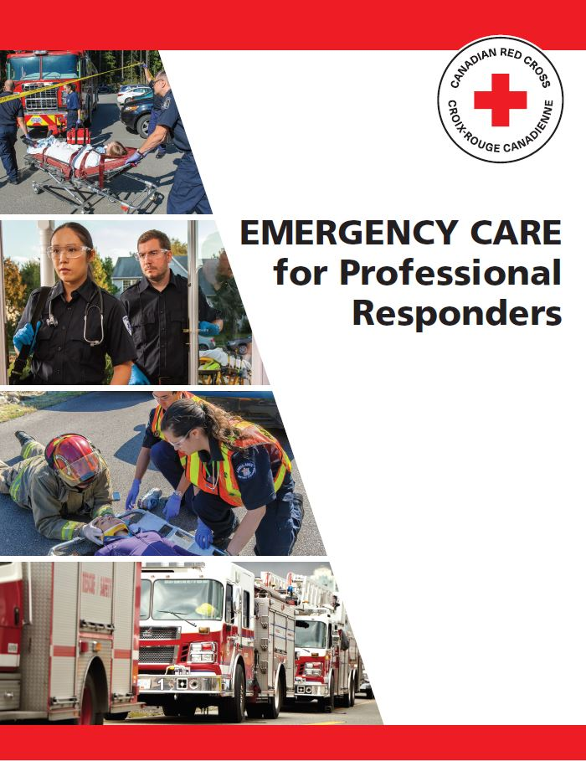

SPORTS FIRST RESPONDER COURSE REGISTRATION

First Middle Last Name:

Mobile Phone:

E-mail:

LEVEL OF TRAINING

☐ AT ☐ AT Student ☐ CATA ☐ CPR ☐ Standard First Aid
☐ DC ☐ DC Student ☐ RCCSS(C) ☐ EMR ☐ Occupational First Aid
☐ MD ☐ MD Student ☐ CASEM ☐ BTLS ☐ First Responder
☐ RMT ☐ RMT Student ☐ CSMTA ☐ PHTLS ☐ Sports First Responder
☐ PT ☐ PT Student ☐ SPC ☐ Life Guard ☐ Ski Patrol
☐ RN ☐ RN Student ☐ Other

SPORTS FIRST RESPONDER COURSE

☐ $495 SFR Certification Course October 18-20, 2019 Lifemark Physiotherapy West Kelowna, BC
☐ $395 SFR Re-Certification Course October 19-20, 2019 Lifemark Physiotherapy West Kelowna, BC

PAYMENT

Email registration form to stanleyleene@hotmail.com

Email your Interac eTransfer payment to stanleyleene@hotmail.com

Make payment cheque payable to: Stanley P. Leene
110 Somerset Park SW
Calgary, Alberta
T2Y 3H5
403.589.2233

CANCELLATION AND REFUND POLICY

- A refund (less a $50.00 cancellation fee) will be provided only if a notice of cancellation is received more than
14 days prior to the course date.
- No refunds will be provided after 14 days prior to the course date. (NO EXCEPTIONS!)
- Courses are subject to cancellation: if a minimum number of registrations are not received;
in the event of unavoidable acts of nature and/or weather;
or due to instructor medical illness, injury or emergency.
- We are not responsible for travel or accommodation costs booked in advance of the course.

